**输入字段 (Input Field)**

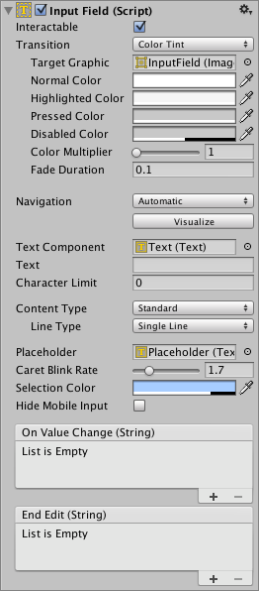

**属性**

| ***属性：*** | | ***功能：*** |
| --- | --- | --- |
| **Interactable** | | 一个用于确定输入字段是否可交互的布尔值。 |
| **Transition** | | Transitions are used to set how the input field transitions when ***Normal***, ***Highlighted***, ***Pressed*** or ***Disabled***. |
| **Navigation** | | Properties that determine the sequence of controls. See Navigation Options. |
| **TextComponent** | | 对用作*输入字段*内容的文本元素的引用 |
| **Text** | | 起始值。开始编辑前置于字段中的初始文本。 |
| **Character Limit** | | 可在输入字段中输入的最大字符数的值。 |
| **Content Type** | | Define the type(s) of characters that your input field accepts |
|  | **Standard** | Any charcter can be entered. |
|  | **Autocorrected** | The autocorrection determines whether the input tracks unknown words and suggests a more suitable replacement candidate to the user, replacing the typed text automatically unless the user explicitly overrides the action. |
|  | **Integer Number** | Allow only whole numbers to be entered. |
|  | **Decimal Number** | Allow only numbers and a single decimal point to be entered. |
|  | **Alphanumeric** | Allow both letters and numbers. Symbols cannot be entered. |
|  | **Name** | Automatically capitalizes the first letter of each word. Note that the user can circumvent the capitalization rules using the **Delete** key. |
|  | **Email Address** | Allows you to enter an Alphanumeric string consisting of a maximum of one @ sign. periods/baseline dots cannot be entered next to each other. |
|  | **Password\*** | Conceals the characters inputed with an asterisk. Allows symbols. |
|  | **Pin** | Conceals the characters inputed with an asterisk. Only allows only whole numbers to be entered. |
|  | **Custom** | Allows you to customise the Line Type, Input Type, Keyboard Type and Character Validation. |
| **Line Type** | | Defines how test is formatted inside the text field. |
|  | **Single Line** | Only allows text to be on a single line. |
|  | **Multi Line Submit** | Allows text to use multiple lines. Only uses a new line when needed. |
|  | **Multi Line Newline** | Allows text to use multiple lines. User can use a newline by pressing the return key. |
| **Placeholder** | | 这是一个可选的“空”图形，用于表明*输入字段*不包含文本。请注意，即使选择了*输入字段*（即获得焦点），仍会显示此“空”图形。如：“Enter text…”。 |
| **Caret Blink Rate** | | 定义该行上的标记的闪烁速率（用于指示建议插入文本）。 |
| **Selection Color** | | 所选文本部分的背景颜色。 |
| **Hide Mobile Input (iOS only)** | | Hides the native input field attached to the onscreen keyboard on mobile devices. Note that this only works on iOS devices. |
|  |  |  |

**事件**

| ***属性：*** | ***功能：*** |
| --- | --- |
| **On Value Change** | 输入字段的文本内容发生变化时调用的 UnityEvent。该事件可将当前文本内容作为 string 类型动态参数发送。 |
| **End Edit** | 用户完成文本内容的编辑（通过提交操作或单击某个位置以将焦点移出输入字段）时调用的 UnityEvent。该事件可将当前文本内容作为 string 类型动态参数发送。 |